GERMANY

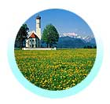
After more than a decade of putting itself back together again, Germany continues to improve as a holiday destination. A lot has changed, yet repeat visitors still find the things they always liked and more. Like those who have visited before, you’ll be charmed by its people & its beauty. Germany oozes big-city charm, small picture-postcard towns, wonderful harvest festivals, a wealth of art and culture and the perennial pleasures of huge forests, delightful castles and fine wine and beer. In the south, the Alps attract ski-lovers in winter and hiking enthusiasts in summer. Water-sports are another popular pastime and the country offers terrific facilities for adventures of this kind, be it on a lake, the sea or a river. Discover it better via these pages before you go.

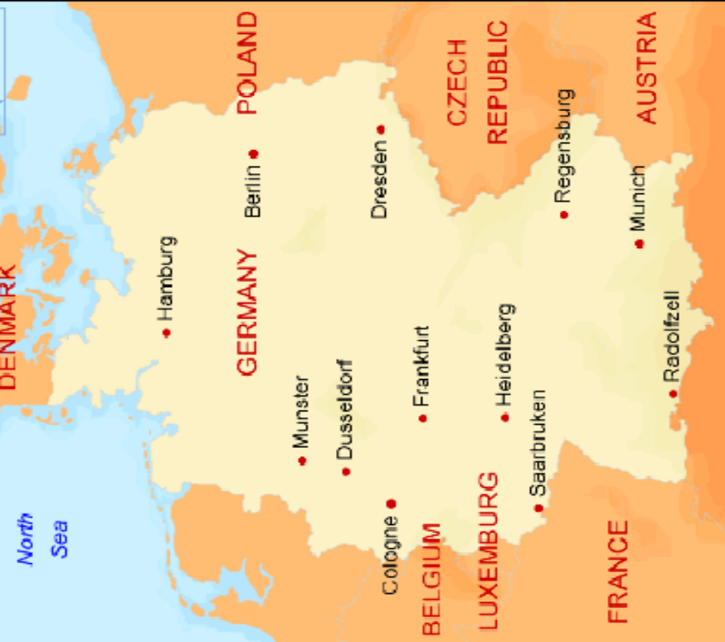

Informative Websites:
http://www.hoteltravel.com/germany/guides/tips.

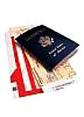
Visa: The visa is to be obtained prior to arrival in the country

How to get there:
Air: Main airports are Frankfurt, Munich & Dusseldorf
Train: Intercity (IC) trains connect the country well.
Car: Country is connected with excellent highways
Ferry: Rhine is Main River besides Main, Danube & Mosel.
Bus: Busses operated by Bahnbus.
Germany has excellent roads. The national network and the motorway network is known as Autobahnen.

Regions in Brief
- Northern Germany’s biggest city is Berlin followed by Hamburg which is the third largest city.
- Bavaria region is the most prosperous with Munich as the capital. Other regions include the Romantic Road, Fussen and the Black Forest region.
- Western Germany famous for its history and ancient cities like Heidelberg, Stuttgart, Nuremberg and Cologne.
-Southern Germany’s main city is Munich, the second largest city.

INTERNATIONAL AIRPORT:
City | Airport Name | Distances
Berlin | Tegel International Airport | 08 km northwest of Berlin citycentre
Berlin | Berlin-Schonefeld Airport | 19 kms southeast of City centre (Brandenburg)
Berlin | Berlin-Tempelhof International Airport | 06 km southeast of city centre
Frankfurt |  | 11km from citycentre
Munich | Franz-Josef-Strauss Flughafen | 48 kms to Milan City centre
Cologne | Cologne Bonn Airport | 15 km southeast of Cologne and 16 km northeast of Bonn.
Dusseldorf | Düsseldorf International Airport | 09 kms from Dusseldorf city centre
Hamburg | Hamburg Airport | 8.5 km north-west of the citycentre

Distances between Germany cities:

Cities | Kms | miles | By Air | By Train
Berlin – Frankfurt | 569 | 354 | 45 mins | 2.30 hrs | Berlin hauptbahnhoff – Koln hauptbahnhof
Berlin - Dusseldorf | 571 | 355 | 1 hr | NA | NA
Berlin – Hamburg | 287 | 178 | 1.25hrs | NA | NA
Berlin – Munich | 583 | 363 | 45 mins | NA | NA
Berlin – Cologne | 575 | 357 | NA | 4 hrs 18 min | Berlin hauptbahnhoff – Koln hauptbahnhof
Bonn – Cologne | 480 |  | 1 hr | NA | NA
Frankfurt - Cologne | 230 |  | NA | 1 hour 14 min. | Frankfurt Main hauptbahnhoff – Koln hbf
Munich – Cologne | 460 |  | 1hr | 4 hrs 28 min | Munchen hauptbahnhoff – Koln hbf

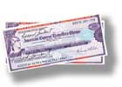
Currency:
The Euro is now the official currency of 12 EU member states (including Germany). Euro (€) = 100 cents. Notes are in denominations of €500, 200, 100, 50, 20, 10 and 5. Coins are in denominations of €2 and 1, and 50, 20, 10, 5, 2 and 1 cents.
Currency Exchange Foreign currencies and travelers cheques can be exchanged at banks, bureaux de change, post offices, airports, railway stations, ports and major hotels at the official exchange rates.
Credit and Debit Cards These are accepted in approximately 60 per cent of all shops, petrol stations, restaurants and hotels.
Travelers Cheques generally provide the best rate of exchange. To avoid additional exchange rate charges, travelers are advised to take travelers cheques in Euros, Pounds Sterling or US Dollars. Currency Restrictions There are no restrictions on the import or export of either local or foreign currency. Banking Hours Generally Mon, Tues, Wed and Fri 0830-1300 and 1430-1600, Thurs 0830-1300 and 1430-1800 in main cities. Main branches do not close for lunch.

Climate:
A fine destination year round, most people visit between May and September when sunny skis are most likely and much life moves outdoors. The shoulder season (from March to May and October to early November) bring fewer tourists, lower accommodation prices. In April and May the climate is mild and sunny.

Berlin | Jan | Feb | Mar | Apr | May | Jun | Jul | Aug | Sep | Oct | Nov | Dec
Min Temp (°C) | -3 | -2 | 0 | 2 | 7 | 11 | 13 | 12 | 10 | 5 | 1 | -1
Max Temp (°C) | 2 | 3 | 8 | 13 | 19 | 22 | 22 | 22 | 18 | 13 | 7 | 3

Frankfurt | Jan | Feb | Mar | Apr | May | Jun | Jul | Aug | Sep | Oct | Nov | Dec
Min Temp (°C) | -2 | -1 | 2 | 3 | 7 | 11 | 13 | 13 | 10 | 6 | 2 | 0
Max Temp (°C) | 3 | 5 | 10 | 14 | 19 | 22 | 24 | 23 | 20 | 14 | 7 | 4

Munich | Jan | Feb | Mar | Apr | May | Jun | Jul | Aug | Sep | Oct | Nov | Dec
Min Temp (°C) | -5 | -3 | 0 | 3 | 7 | 11 | 13 | 12 | 9 | 4 | 0 | -2
Max Temp (°C) | 1 | 3 | 9 | 11 | 18 | 21 | 23 | 23 | 18 | 12 | 6 | 3

Hamburg | Jan | Feb | Mar | Apr | May | Jun | Jul | Aug | Sep | Oct | Nov | Dec
Min Temp (°C) | -1 | -1 | 1 | 2 | 7 | 10 | 12 | 12 | 9 | 6 | 3 | 0
Max Temp (°C) | 2 | 3 | 7 | 11 | 16 | 19 | 21 | 21 | 17 | 12 | 7 | 4

Time:

Germany is 4 hours and 35 minutes behind India.

Clothing:
Bring comfortable shoes, a sweater, clothes you can layer and an all-weather coat. On the cruises, informal dress is the general rule but there may be some occasions were formal dress is required.

Electricity:
Electricity 230 volts AC, 50Hz.

Dialing code:
The country code is: 49
the city code is: 30

Tipping

Germans generally round up €1 when tipping. However, tipping is not practiced as liberally as it is elsewhere. Most Germans only tip in restaurants and bars, or when they are the beneficiary of a service, such as a taxi ride. Note that tips in Germany are not left lying on the table, but handed directly to the server when you pay.


Language:
German is the main language. English is widely spoken

Events
From pagan harvest romps to black tie opera galas, Germans are keen to party. Winter festivals occur throughout Germany, with big cities such as Cologne, Munich and Mainz erupting into carnival commotion just before Ash Wednesday. Germany's rich musical heritage is showcased in a plethora of festivals. Some towns concentrate on a particular composer, such as the Thuringian Bach Festival in March or the Richard Wagner Festival in Bayreuth each July, whereas others focus on a particular style. The jazz festivals in Frankfurt (March), Stuttgart (April) and Berlin (October) are lively and popular. Autumn is a great time for harvest-inspired mayhem, especially in the Rhineland, where the Rhine in Flames Frolics feature barges laden with fireworks. Mention must be made of Oktoberfest, Munich's annual lager frenzy, but it's a bit like being stuck in a nightmarish soccer crowd and is more an example of tourism at its lowest ebb than a display of German culture. Most towns in Bavaria have festivals devoted to beer and they're much nicer than Oktoberfest. Christmas celebrations are embraced wholeheartedly by German families, most extravagantly in Munich, Nuremberg, Essen and Heidelberg.

CITIES:

Berlin

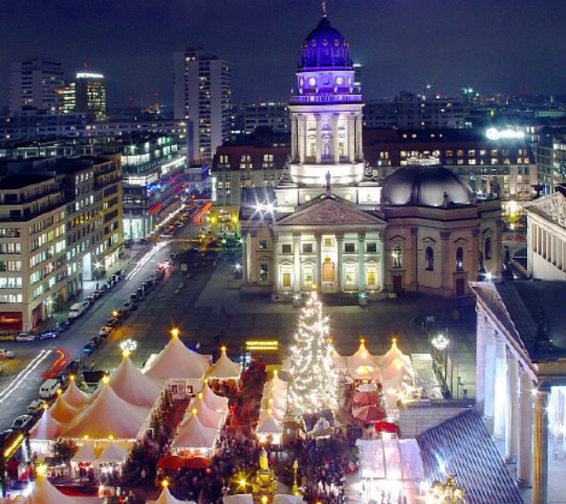

Berlin is the capital city and one of the sixteen states of the Federal Republic of Germany. It is the heart of the Berlin-Brandenburg metropolitan region, located in northeastern Germany. With a population of 3.4 million in its city limits, Berlin is the country's largest city, and the second most populous city in the European Union. The metropolitan area comprises a population of between 4 and 5 million people, coming from over 180 nations
The eternal city is the seat of the papacy and the capital of the Christian world, and combined with it’s more than 2000 years of history, exquisitely rich artistic and architectural patrimony of Rome can often leave a tourist feeling overwhelmed.
UNESCO Berlin joins Buenos Aires as the only “City of Design” worldwide (UNESCO title awarded January 2006)􀂃First German city to be appointed to the “Creative Cities Network” Honors remarkable social,economic and cultural achievements in the field of design.

Getting Around
Air: Tegel is the busiest airport followed by Tempelhof & Schonefeld .
Train:. Has several high seed train coming into the city. Two main lines are Bahnhof Zoologischer Garten (western zone ) and Berlin Ostbahnhof ( eastern zone ) .
Bus: Has convenient bus connections but are rather slow and comfortable
Taxi: Easily available .
Ferry: F10 , ferry service shuttles between Kladow to Wanness .

City Layout
- The center of activity is west Berlin is Kurfurstendamm , a wide boulevard.
- Schloss Charlottenburg area and its museums is a major sightseeing area .
- Strasse des 17 juni runs through Tiergarten Park and leads to the famous Brandenburg Gate
- The Brandenburg Gate is the start of eastern Berlin’s most celebrated street Unter den Linden . It runs from west to east , leading to the Museum island .

Attractions

Brandenburg Gate
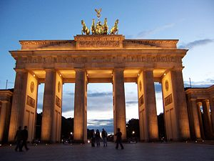
The impressive and symbolic Brandenburg Gate that lay forlon for so long in the no man’s land behind the Berlin Wall is now once again renovated and accessible, along with the newly reconstructed Pariser Platz that links the gate to the beautiful Unter den Linden Boulevard.The Brandenburg gate is probably the most well-know landmark in Berlin, it now stands as a symbol of the reunification of the two sides of this great city. Location: Paiser Platz at Unter de linden

Checkpoint Charlie

The famous border crossing point in the wall dividing West and East Berlin has now become a shrine to the wall’s memory with addition of a museum, Haus Am Checkpoint Charlie.
Location: Friedrichstrasse 43-44, 10969 Berlin
Subway U6 Kochstr., U2 Stadtmitte
open hours: daily 9am - 10am

Eastside Gallery

The remains of the Berlin Wall have now become the largest open-air art gallery in the world. The longest section of the wall, which has been preserved, stretches from Ostbahnhof station to the Oberbaumbrucke, and has been given over to graffiti artists from around the world.

Potsdamer Platz

This vibrant square is the heart and soul of the ‘New Berlin’, which has emerged since the fall of the wall in 1989. Postdamer platz, now boasts and exciting mix of restaurants, as hopping centers, hotel and cinemas. Focus of the square is the 22 storey Debis Haus, designed by Renzo Piano, featuring an atrium with cathedral-like dimensions, and its neighbouring Potsdamer Platz Arkaden, a shopping mall with an Imax cinema.

Reichstag

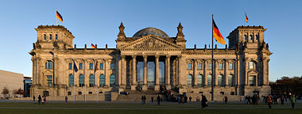

Berlin's Reichstag is home to the German parliament and became a major tourist attraction after 1999, when Norman Foster's fabulous glass dome on top of the building opened to the public.

Hamburger Bahnhof

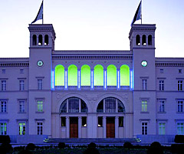
This gleaming white museum is one of the best collections of contemporary art in Berlin. The Hamburger Bahnhof is housed in a converted train station. The Hamburger Bahnhof: built in 1845-47 as terminus of the Hamburg to Berlin railway, is sited in Berlin. The original buildings, a combination of late Neo-Classical masonry with the iron skeleton of the platform hall, were closed in 1884. Between 1904 and 1906, the station was converted into a transport and engineering museum. It houses one of the largest private collections of contemporary art in the world including over 2,000 works of art by around 150 different artists.

Berlin Zoo
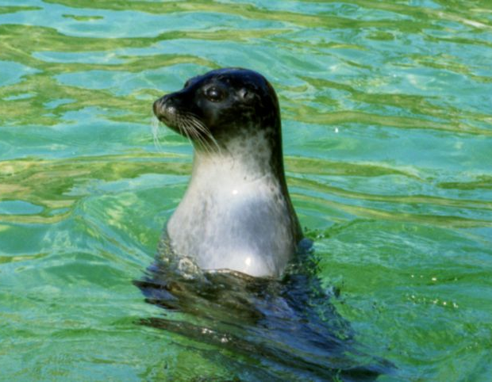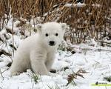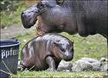

The Zoologischer Garten Berlin (Berlin zoological garden) is one of the biggest zoos in Germany and with the largest number of species of the world. Today the zoo houses approximately 14,000 animals from 1500 species on a 35 hectare site in historical animal houses. Highlights include giant pandas, which can only be seen at a few zoos in the world. All of the animals are housed in enclosures that are specially designed to recreate their natural habitat. The Berlin Zoo is the most visited zoo in Europe with visitors from all over the world. It is open all year long and can easily be reached by public transportation. Visitors can either enter the zoo through the exotically designed Elephant Gate beside the aquarium on Budapester Straße or through the Lion Gate on Hardenbergplatz Child 3 & under are Free of Charge. It is located in Berlin Tiergarten near the S-Bahn and railway station in the city center.
To get there: U-Bahn: Tierpark (U5); Tram: 17, 80; Bus: 294.
Website: http://www.zoo-berlin.de/
Category .
Aviary, bird museum or exhibit
Castle, chateau, palace
Garden or botanic display
Musical activity or concert hall
Zoo or animal collection

Jewish Museum

If you only visit one museum during your time in Berlin, make it this one. Museum covers some two millennia of German Jewish history and is the largest of its kind in Europe. The main emphasis is on culture, art and science and the 14 different sections cover every major historical period. The Holocaust Tower is the most powerful part of the museum. Designed by Daniel Libeskind, it is place of quiet and stony stillness that subtly conveys the horrors of the past. This is an unsettling and haunting place and one that you owe it to yourself to visit.

Excursions

Potsdam

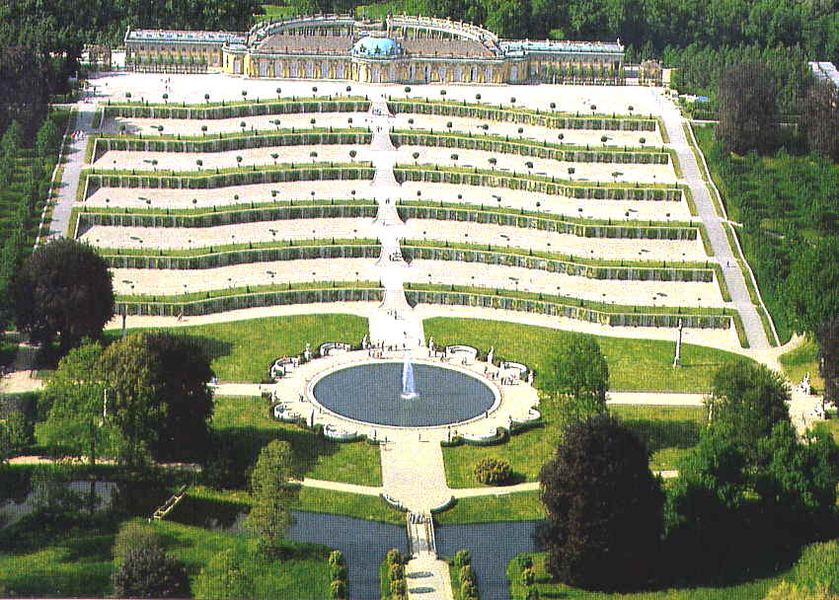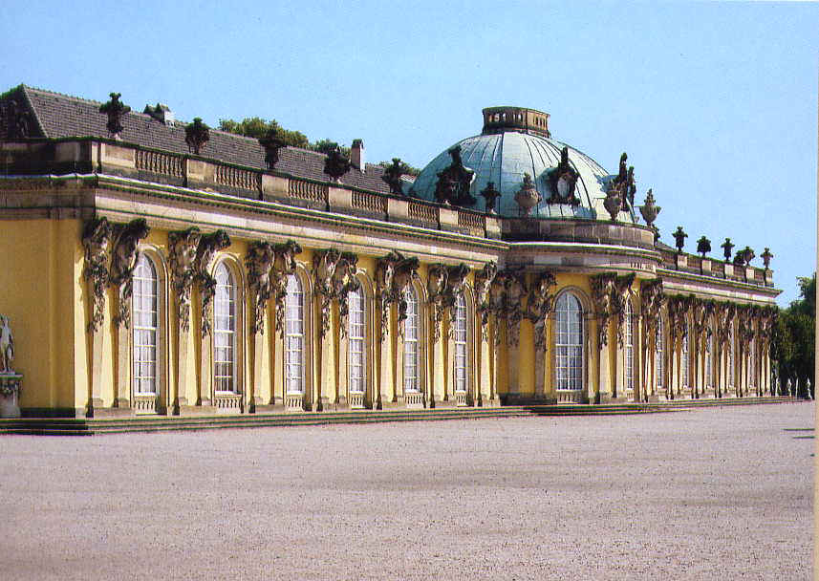

One of the best excursions from Berlin is a visit to Potsdam, with its pleasant main shopping street and Dutch Quarter, as well as nearby palaces and gardens of Sanssouci of King Fredrick’ s summer residence. Potsdam is located approximately 20 kms from Berlin city centre and is reachable by S-Bahn S7 or the regional train RE1, both leaving from Bahnhof Zoo.

Spreewald
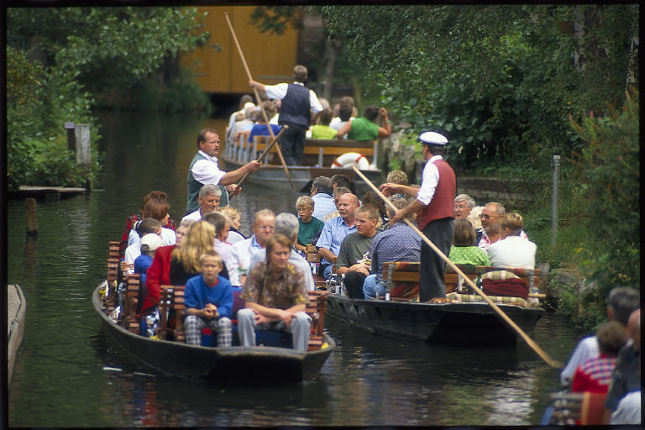
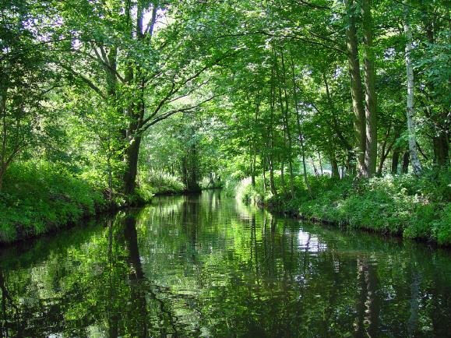

To the south east of Berlin lies the nature reserve of the Spreewald (Spree Forest). The best place for one to start the tour is from the large harbour in Lubbenau or one of the smaller ones in Lubben or Burg. Spreewald is located 110 kms from Berlin. Regional trains depart from Konigs Wusterhausen in SouthEast Berlin (journey time-40 min) and from Bahnof Zoo (journey time 1 hour 30 min.) and Oustbahnhof (journey time – 1 hour)

Events:

Berlin Love Parade

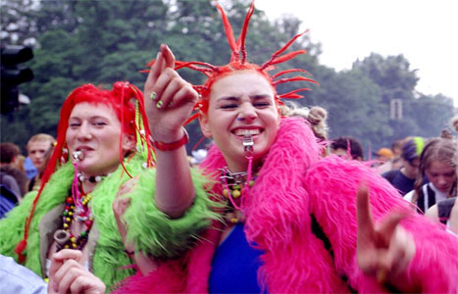
The Love Parade began life as something of a political movement way back in the summer of '89, and four months before the fall of the Berlin Wall. It was organised on the initiative of Matthias Roeingh, aka "Dr. Motte", a DJ of the Berlin underground scene who wanted to use the international language of music as a medium for spreading peace and love, and promoting world unity. In his words: "Music knows no boundaries or nationalities."

Carnival of Cultures

The street parade will take place on June 4th from 12.30pm to 9pm, attracting more than 4,000 participants from 70 countries. Live musicians, stiltwalkers and jugglers will all help to keep the massive crowd entertained. Music, dance, masks and theatre all play their part in the celebrations, with a particular focus on the electronic music for which Berlin is renowned. The entire festival lasts from June 2nd to 5th, with four separate stages and some 380 food, drink and craft stalls to choose from.

Festival of Lights

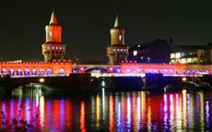

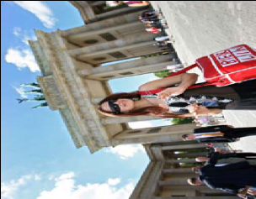
The FESTIVAL OF LIGHTS™ turned Berlin into a sparkling metropolis with a firework of illuminations and events for two weeks from 16 to 28 October. World-famous historical landmarks and spots in Berlin, e.g. the Brandenburg Gate, the TV or radio tower, was staged impressively by means of light, events, projections and fireworks. Complementary to the festival there were numerous cultural events dealing with the subject “light”. The lights of the festival are extinct for this year, but next year they will enchant Berlin again in the last weeks of October (from 14 to 26 October). The FESTIVAL OF LIGHTS™ included more than 40 sights, squares and buildings spreading a magic light strip all over the city from East to West, among others Brandenburg Gate, Victory Column, German, French and Berlin cathedral, etc.

Shopping:
More than18, 000 shops, Shopping from Monday to Saturday until8 p.m.
Various malls and shopping streets: Kurfürstendamm, Friedrichstrasse, Potsdamer Platz

Indian Restaurants
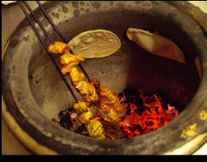
- Indianhaus –
Feurigstraße 38-39
10827 Berlin
http://www.restaurant-indiahaus.de

- Calcutta –
Bleibtreustr.17, 10629 Berlin

Frankfurt

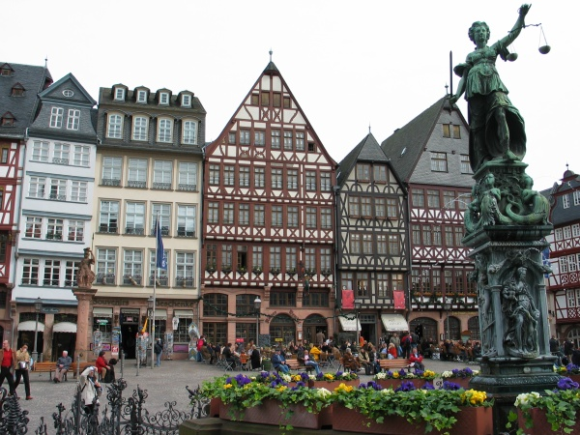
Frankfurt is the largest city in the German state. Located on the river Main, Frankfurt is the financial capital of Europe and the transportation centre of Germany.
Frankfurt is often seen only as a transit hub or a business centre, but it’s so much more. It boasts Germany’s most spectscular skyline, mirrored in the Main River, and Europ’s tallest office building.
The best times for Frankfurt are late spring to early autumn. The summers tend to be sunny and warm around 25 degrees celsius. Be prepared, however, for very hot summer days around 35 degrees as well as for light rain. The winters can be cold and rainy (usually not lower than -10° C), but there is hardly any snow inside Frankfurt itself.
If you plan to stay overnight, you may wish to avoid times when trade fairs are held, as this will make finding affordable accommodations a challenging task.

Getting There
Regular flights from all over the world come into Flughafen Frankfurt/Main airport , 11Kms from city. This airport is one of the busiest airport in the continent of Europe and is Germany’s International gateway. There are German InterCity trains and S-Bahn commuter trains to Frankfurt and nearby cities from the airport.
Frankfurt’s main train station is Hauptbahnhof , is also the busiest in Europe
There is also regular coach service that connect the cites well.

City Layout:
Stadmitte is the town center known for its nightlife, restaurants, hotels.
Old town area has all the major sightseeing attractions.
Romerberg is the historical core of the city and is a good place to start your sightseeing.

Getting Around:
The public transport system is excellent and integrates the city’s bus , tram , S-Bahn and the U-Bahn lines

Attractions

Goethe House
Goethe House (completely rebuilt on the basis of old plans in 1946-51), in which the great German writer Johan Wolfgang vin Goethe, was born on August 28, 1749, and lived until 1765. The interior (now a museum) has been restored to its original condition. Location: Goethe House,Grosser Hirschgraben 23-25, D-60311 Frankfurt am Main.
Opening hours: Mon-Sat &10 am – 6.00 pm; Sun and public holidays -10 am – 5.30 pm

Zoologische Garten

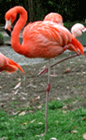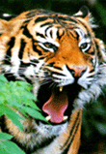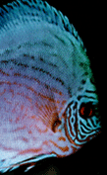
Zoo is open every day:
Like an oasis of nature right in the city, Frankfurt Zoo shows a rich variety of rare species and unique buildings. The zoo concentrates on choice species, since space ist strongly limited and big herds and wide landscaped enclosures cannot be presented.
Frankfurt Zoo is one of the oldest zoos in the world and became famous for breeding rare species like okapis, maned wolfs, black rhinoceroses and Amur leopards, but typical animals like bears, pinnipeds, antelopes and birds of prey are presented as well. Two restaurants provide for your culinary welfare in the Zoo: the Snack Bar/ Cafeteria Happy Bar and the Mexican Restaurant Sombrero im Zoo. Summer
Our Zoo is open daily 9:00 am –7:00pm
Main Entrance ticket office daily 9:00 am –6:30 pm
Rhonstrasse ticket office daily 10:00am –5:30pm Winter
Our Zoo is open daily 9:00am –5:00pm
Main Entrance ticket office daily 9:00 am –4:30 pm
Rhonstrasse ticket office daily 10:00am –3:30pm

Botanical Gardens

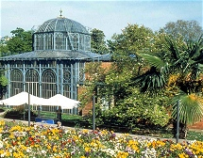

The well ordered and interesting Botanical Garden in Frankfurt is administered by the University. The gardens are designed to take the visitors on a journey through different areas of the plant kingdom, from the hardwood forest of North America to the barren Savannah of Africa.

Excursions

Wiesbaden

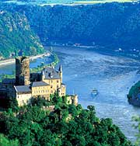
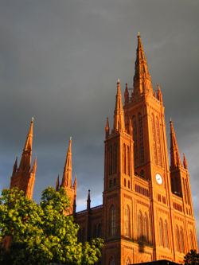

Beautifully situated between the Taunus highlands in the north and the Rhine in the south. It is beautiful, elegant and vibrant city where sports and the arts are equally at home. Its 26 hot springs were already worth a mention for the writers of ancient Rome, and today Wiesbaden combines the attractions of a modern conference and trade fair venue with the old-world charm of one of the great spas of yesteryear - and a rich historical heritage including imposing ruins, castles, churches and other monuments.

The Rhineland

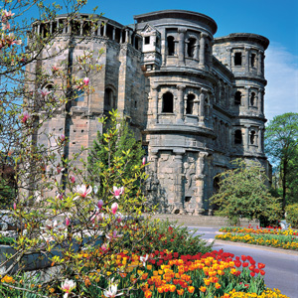

The Rhine River has always served as a major trading route, and it is also a favourite with tourist who enjoy cruising particularly along its scenic mid section between Mainz and Koblenz. Boarding a steamer in Mainz, about 40 km south west of Frankfurt, one journeys through steep vine covered hillsides dotted with romantic towns and castles, many associated with fascinating legends and fables.

Trier

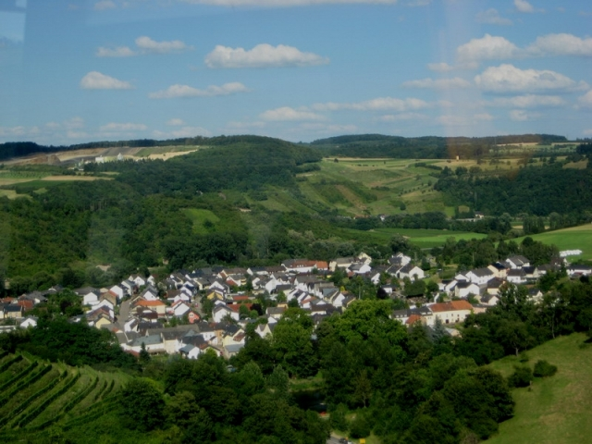

A taste of ancient Rome is a popular tourist attraction in the German city of Trier, 193 km south west of Frankfurt. The city is also a good starting point for trips into the Moselle valley, and cruises on the scenic Mosel River, which
Germany’s main wine-producing region.

Heidelberg

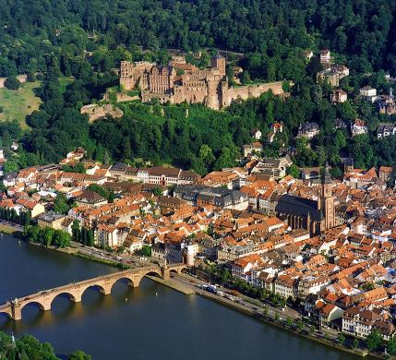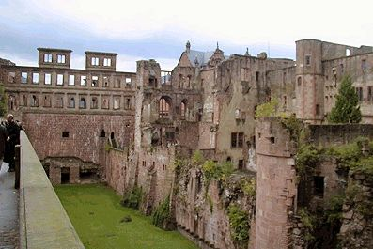

It is approximately 1 hour by train from Frankfurt.The historic university town of Heidelberg, about 98 km south of Frankfurt, is called as a city of music and romance. The city is built along the banks of the Neckar River, and has a colourful atmosphere lent by its large student population and it is well known for its beautiful castle.

Indian Restaurants

Mayur Indian Restaurant
City Centre. Turbans, high backed throne-like chairs and the fantastic smell of curry reside at the Mayur, along with the colors of India, royal red and whites. The menu is extensive, and the buffet makes it easy to sample a variety of excellent dishes
Address:Berliner Strasse 10, Frankfurt, Germany 60311 ·

Palace of India
Vilbeler Strasse 27
60313 Frankfurt am Main

Banjara
Address:Hainer Weg 7
60599 Frankfurt am Main

Indigo Indisches Restaurant
Address:Taunusstr 17
60329 Frankfurt am Main
www.in-indigo.com

Bombay Palace
Address: Abtsgäßchen 8
60594 Frankfurt am Main
www.bombaypalace.de

Shirin
Address: Glauburgstrasse 27
60318 Frankfurt am Main

The ivory club
Address: Taunusanlage 15
60325 Frankfurt am Main
http://www.ivory-club.de/ivory/index.html

Himalajahaus
Address: Sindlinger Bahnstr. 83
65931 Frankfurt am Main

Teelirium
Address: Berger Str. 104
60316 Frankfurt am Main
www.teelirium.de

Jewel of India
Address: Wilhelm-Hauff-Straße 5
60325 Frankfurt am Main

Munich

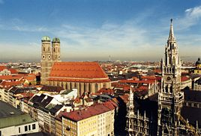

Getting there:
Main airport is Franz-Josef-Strauss Flughfen
There are excellent train connections from major European cities to Munich.

Getting Around
Walking along the central pedestrian zone from Hauptbahnhof to Marienplatz can be an option to explore the city or catch a ride on the public transport .

Attractions

Hofbrauhaus

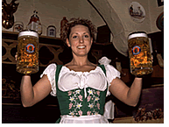
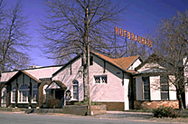

Beer has been swilled at this world-famous tavern site in the centre of Munich since it became a royal brewery in 1605. the cheerful atmosphere that reigns constantly in the establishment’s different halls is helped by the foot-tapping strains of traditional Bavarian ‘oom-pah’ bands and drinking songs.Hofbrauhaus hasFine Bavarian and International Cuisine,Premiere draught and bottled European bier selection,Over 300 exceptional bottled vintages and Traditional Bavarian architecture and authentic costumes
Lunch - Tues - Fri, 11:30a.m. - 2:30p.m.
Dinner - Sun thru Thurs, 4:00p.m. - 9:00p.m. , Fri & Sat, 4:00p.m. - 10:00p.m.
Brunch is served every Sunday from Thanksgiving through FATHERS DAY from 11:30a.m. Until 2:30p.m.

Marienplatz

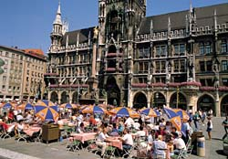

The Marienplatz is the heart of Munich and the site of its most important historical buildings. The square is dominated by the Neo-Gothic Town Hall featuring its famous Glockenspiel, both built in the 19 century.

Olympia Park

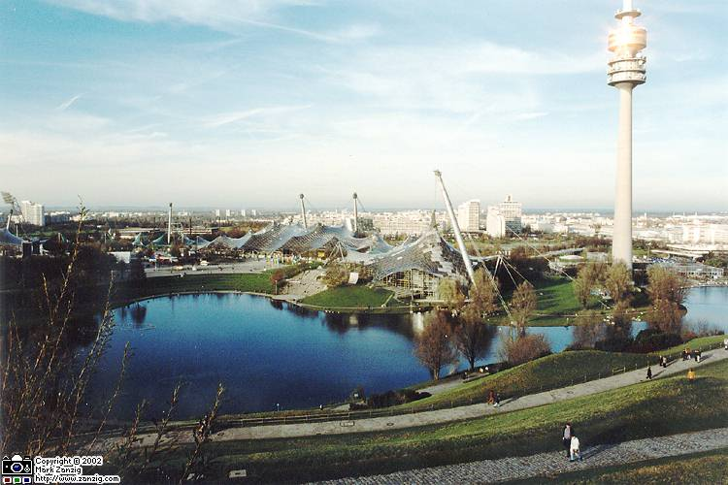
Munich’s massive Olympic park complex was constructed for the 20th Olympic Games in 1972, but remains a marvel of modern engineering. Visitors to the site can enjoy a spectacular view from the revolving restaurant and observation terrace which tops the 950 feet high Olympic Tower. Near the tower is the BMW Museum, which displays the history of Germany’s famous automobile manufacturer.
Nymphenburg Palace

Asam Church

This beautiful Rococo church, dedicated to St John of Nepomuk, was built between 1733 and 1746 by the brothers Cosmas Damian and Egid Quirin Asam and richly decorated with stucco ornament, stucco figures, frescoes and oil paintings. It was restored at great expense between 1975 and 1982. This is a ceiling shot showing the magnificent paintings and gold trim.

Excursions

Neuschwanstein Castle

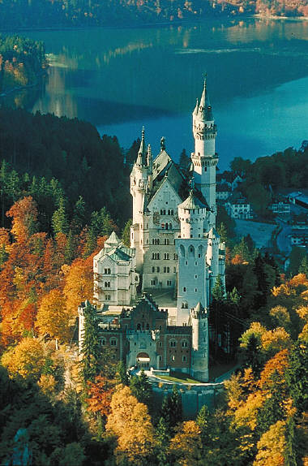

The fairy tale castle built by King Ludwig II has become the trademark of the German state of Bavaria, with its Gothic wedding – cake tiers and towns. Day tours to the castle are available from Munich, or self drive via Garmisch. The interior of the castle is an extravagant as its outer aspect, particularly the King’s apartments, which are decorated entirely with hand-embroidered silk, elaborate walls and ceiling paintings and carvings.

Berchtesgarten

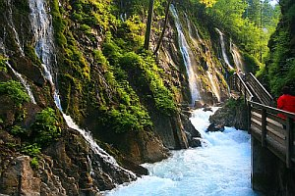

The name Berchtesgarten is most closely associated with Adolf Hilter’s country house, but it is in fact a delightful Bavarian alpine village with ancient winding streets and medieval market place, popular as a side trip from Munich. You can also visit the Wimbachklamm - Waterfalls - this is a part of the Berchtesgaden National Park. Hitler’s Holiday house, the Berghof is actually at Obersalzberg about 2 km from Kehlstein Mountain. Most tourists however do the delight in visiting the Kehlsteinhaus or Eagle’s Nest, a remarkable building perched atop the mountain.

Garmisch – Partenkirchen

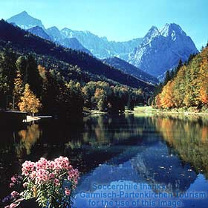
Germany’s top winter sport destination, Garmisch - Partenkirchen is a busy centre. The area is picturesque and scenic, both in winter and summer. It 80 min. by train from Munich.

Romantic Road

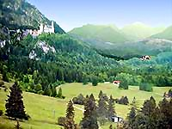
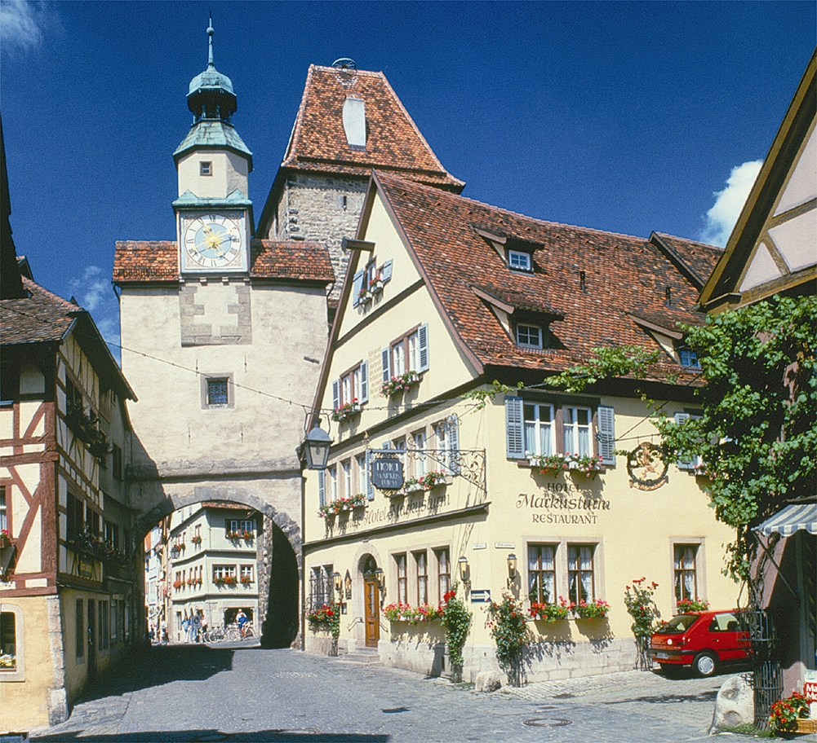

To experience the best of Medieval Germany hundreds of visitors drive along the Romantic Road, 290 km route between Munich and Frankfurt that links together a string of quaint, well preserved walled towns dating back a thousand years or best known of the towns on the Romantic Road is Rothenburg.

Indian Restaurants
1. Saheb – Gallmayer str 2
2. Samrat – Papa-Schmid str 1
3. Swagat – Prinzergentenpl 13

Upcoming Destinations & Attractions

Cologne

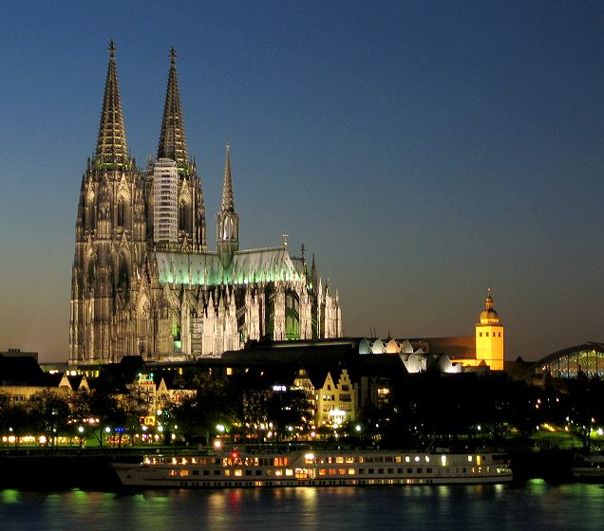
Cologne or Köln, Germany is the fourth largest city in the country behind Berlin, Hamburg, and Munich. Located in the state of North Rhine-Westphalia, Cologne rests along the Rhine River. Cologne is one of Germany's oldest cities. Each year many tourists are attracted to Cologne Germany travel due to its fascinating history. When you visit Cologne Germany you're sure to be enchanted by the blend of Romanesque churches, however, what draws most to visit Cologne Germany is its cathedral. Known as Kolner Dom, this popular landmark is the unofficial symbol for the city. Construction began in 1248 A.D

Dusseldorf

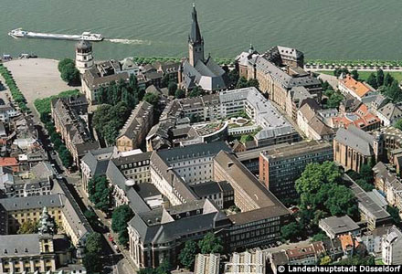

Dusseldorf is a wealthy city - richest in Germany. It’s a commercial city full of Banks, industrial offices and skyscrapers, but it is also refreshingly clean. Düsseldorf is the city of short distances. The various shopping districts can be reached easily on foot.

Hamburg
Hamburg is the second largest city and lays on the River Elbe. The city has a network of canals that rival those of Venice Modern buildings with its historic Baroque and Renaissance architecture and by night the neon lights dazzle all night revelers. Most of the sights of interest to tourists in the city are centered on its maritime traditions, particularly in the harbour area, where the ‘Warehouse district has been transformed into an entertaining destination offering several attractions.

Black Forest

The pine and birch studded mountains of the Black Forest region are alive with fairy tail villages, well equipped spas, and modern ski resorts. The little lakes of Titisee and Schluchsee are popular for boating, swimming and ice-skating. Key destinations are Baden-Baden, Freiburg and Triberg.

